**Electricity Demand Forecasting Using Machine Learning: Covid19 Impact Analysis on Electricity Consumption Pattern**

Forecasting of demand for electricity plays a critical role in Electricity industry as it provides the basis for making important decisions in various parts of the industry including Generation, Transmission, Distribution and Retailing.

Demand for electricity is affected by various factors including meteorological factors as well as socio economic factors. One of the goals of this analysis is to analyze if the global pandemic Covid19 has impacted to significantly change the electricity demand patterns.

For the analysis, electricity demand of Victoria state in Australia has been considered for the period from January 2017 to September 2020. A deep neural network model has been trained to model the pattern using a data set of electricity demand of 1369 days along with other input parameters that were considered listed below.

Electricity demand data: Victoria daily electricity consumption

Meteorological factors: Maximum temperature on a day and Minimum temperature on a day

Base load: Estimated population of Victoria

Business cycles: Weekend, public holiday

Covid19 impact: Covid restrictions applicability

Seasonal impact: demand year, month and date

Electricity demand figures were extracted from AEMO (Ref 1) which is electricity demand of Victoria at 30-minute interval levels which was then aggregated to daily level for the analysis. Daily maximum and minimum temperature data were extracted from Bureau of Meteorology of Australia (Ref 2). Melbourne city temperature figures were used to represent the entire Victoria state.

Estimated population of Victoria was extracted from Australian Bureau of Statistics (Ref 3). Public holidays of Victoria were extracted from data sets provided by Australian Government Digital Transformation Agency (Ref 4).

A parameter indicting Covid restrictions applicability is fed in to the model where from 22nd march 2020 onwards as Covid restricted to analyze its impact to the electricity consumption pattern.

Below in Figure 1 is the entire dataset of electricity consumption scatter plotted.

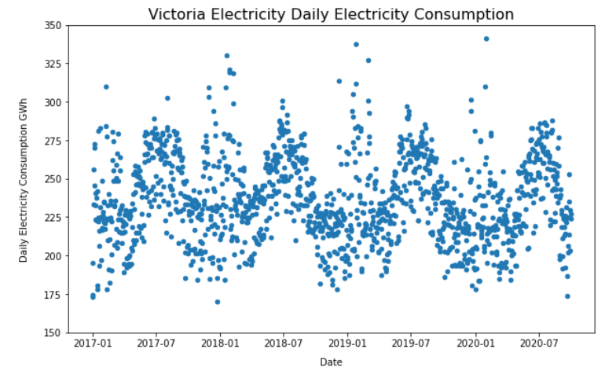

Figure 1: Electricity Demand of Victoria from 2017 Jan to 2020 Sep

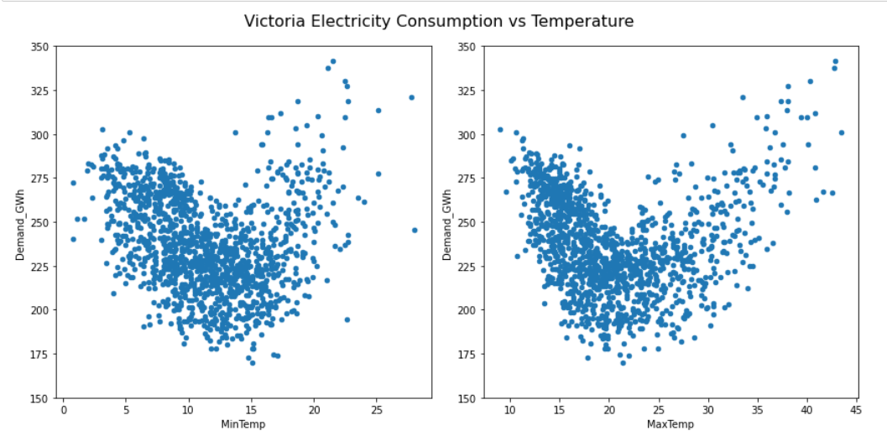

Figure : Electricity Demand of Victoria Vs Temperature

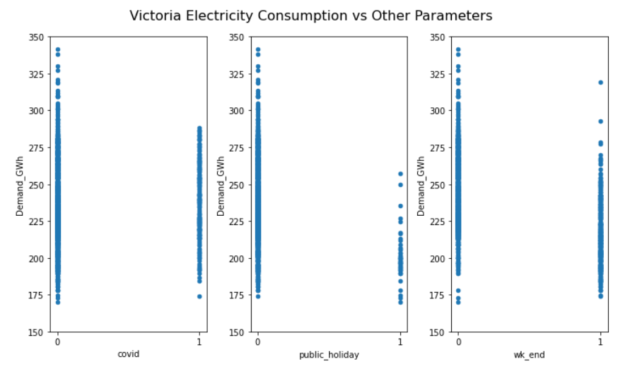

Figure :Impact of Covid Restrictions, Public holidays and Weekend for Electricity Demand

| Parameter | P Value | Statistical Significance |
| --- | --- | --- |
| Min Temperature | 2.5907598534694268e-05 | Statistically significant |
| Max Temperature | 5.2876121462894055e-06 | Statistically significant |
| Covid restrictions | 0.1822682212157099 | Not enough evidence |
| Public holiday | 1.583093822078945e-05 | Statistically significant |
| Weekend | 5.462466627195429e-11 | Statistically significant |
| Population | 0.11746762965270621 | Not enough evidence |

Table : T Test results of parameters considered

On sample data, T Test was conducted to assess the statistical significance of each parameter on the electricity demand. Based on P value obtained for covid parameter had 0.18 which suggested that not enough evidence to eliminate the null hypothesis.

**Deep Neural Network**

Modeling was done using sklearn and tensorflow packages.

All above parameters, demand year, month and date against electricity demand was fed in to a deep neural network.

MinTemp, MaxTemp, wk_end, public_holiday, Population, covid, year, month, day were used as inputs for the model after scaling them using the Standard scalar. Using GridSearchCV, optimum parameter configuration was identified.

Deep Neural network had input layer with 64 neurons and 10 hidden layers with 64 neurons each and one neuron on the out put layer. Loss was calculated using mean squared error and ‘adam’ optimizer was used.

In order to understand the significance of the covid on the models, three configurations were tested.

1. Having covid restrictions as an input parameter (1 or 0) to the model
2. Not having covid restrictions as an input parameter
3. Feeding dataset till March 2020 not having covid restrictions as an input parameter

Table2 contains the performance of the models on each configuration and best performance was observed when covid restrictions parameter was not given as an input to the model for the period covering covid restrictions as well. This suggests that there was no significant impact from Covid restrictions in Victoria impacting the electricity consumption pattern.

| Configuration | R squared | Mean Sq Error | Mean Abs Error | Mean Abs Perc Diff | STD of Abs Perc Diff |
| --- | --- | --- | --- | --- | --- |
| With Covid input | 0.8383 | 118.11 | 8.27 | 3.57% | 3.09% |
| Without Covid input | 0.8578 | 103.91 | 7.82 | 3.38% | 2.89% |
| Dataset before covid | 0.8307 | 122.88 | 8.83 | 3.67% | 2.87% |

Table 2: Model performances on sample Test data

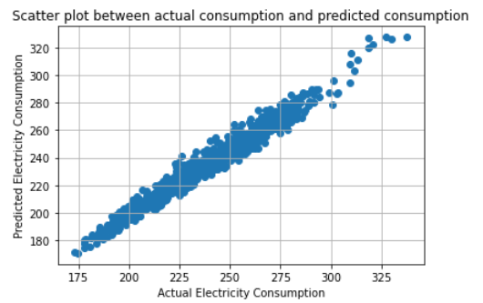

Figure 4: Model predictions vs actuals

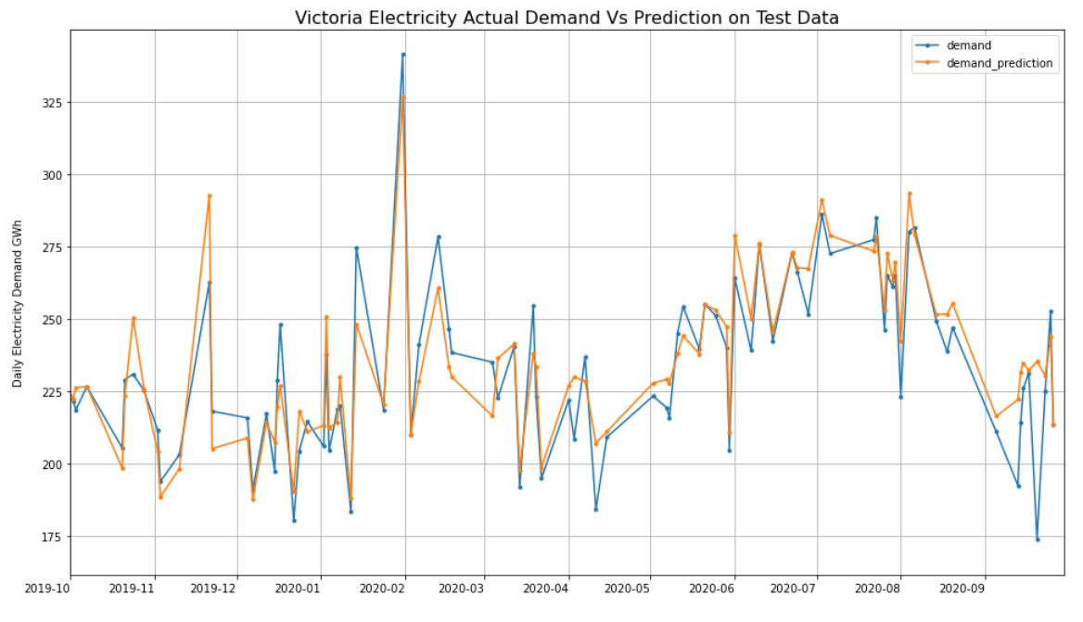

Figure 5: predictions vs actuals

**Conclusion**

Based on hypothesis testing done on electricity demand vs covid restrictions, there was not enough evidence to eliminate the null hypothesis which is there is no significance of covid on electricity demand. Also, based on the performance comparison of Deep Neural Network models (Table 2) not having covid restrictions as an input parameter to the model had best model performance having R squared value of 0.8578. This too suggests that covid restrictions cannot be used to explain variations of Victoria Electricity consumption.

**Possible Improvements**

When considering the temperature data, Melbourne city temperature was considered to represent the temperature of Victoria. If the electricity consumption data can be obtained at smaller granular level, model can be improved by considering the local temperature figures.

A different measure to represent covid impact could be tested such as number of covid patients in Victoria and further analyzed the impact on electricity consumption pattern.

**References**

Ref 1 : <https://aemo.com.au/en/energy-systems/electricity/national-electricity-market-nem/data-nem/aggregated-data>

Ref 2 : <http://www.bom.gov.au/climate/data/>

Ref 3 : <https://www.abs.gov.au/statistics/people/population/national-state-and-territory-population/latest-release#data-download>

Ref 4 : <https://data.gov.au/data/dataset/australian-holidays-machine-readable-dataset>